***EQUIFAX***

CMS Fusion

**JOB XML & JET**

**DOCUMENTATION**

Table of Contents

1. Job XML 2
2. JET 3

# Job XML

The job xml contains all the required details to run a particular job such as the data sources to be used, external files to be used, the models to run, The autopilot modules and other plugins to be run as part of this job and the order in which these steps are to be executed. Various tags in job xml are - <jobIdentifiers>, < jobRuns>, <parallel> etc.

It also contains all the details like the Job name, the credit data set needs to be used, the output tables etc. The XML is being used by the operations team for further processing.

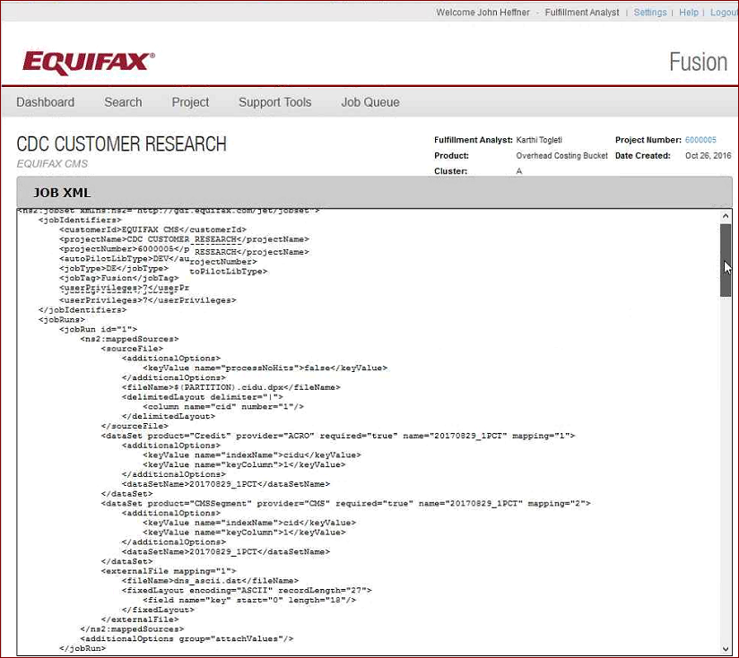

According to the customer requirements it may be necessary to run different score models and attributions on consumer data for a selected list of consumers or for a particular geographical location or for the entire consumers data. The datapump receives these specifications from the CMS fusion in the form of an xml file known as *job.xml*. The datapump then parses the xml specifications, loads various data sources and dynamically loads the shared libraries of the models and attributes to be run as part of the batch job.

Different steps / plugins to be run as part of the batch job will be specified in the job xml along with the details of the datasources to be used. There can be two types of job requests - Source job and Direct extract job. The output of the job is then used to create reports for the customer.

# JET

The CMS fusion requests for the batch jobs as per the requirements from the customer. We use the fusion GUI to create a job request and put across the job xml to JET application.

The role of JET is explained in the below figure, of the fusion ecosystem.

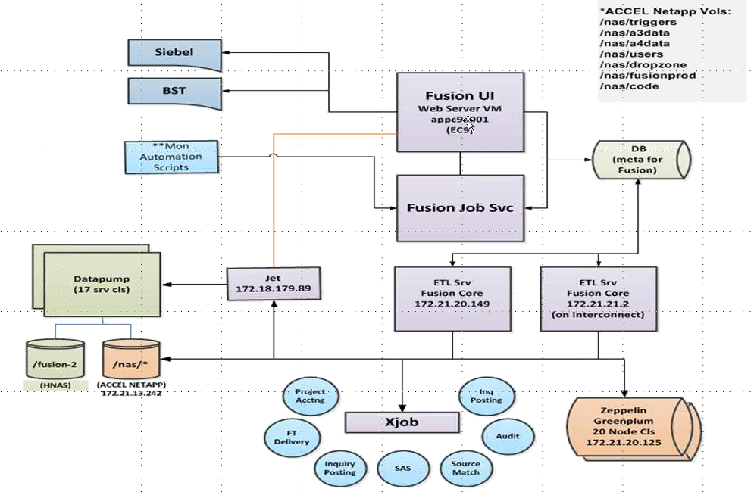

The JET validates these job xmls and the jobs are queued and scheduled to be run in Data Pump. The Data Pump then runs its multisource processor, which takes the job.xml as its input and creates the output. This output is extracted and stored in their Green Plum database, to create reports for the customers.